Confidential
Date: 27 Dec 2012
Version: 0.1

Basic Home Test- Test Bench



V0.2

Revision History
Date | Version | By | Description of Change
27/12/12 | 0.1 | GCS Testing Team | Initial doc

Table of Contents
1 Introduction 5
1. Description of The Document 5
2. Objectives 5
3. Related Documents 5
2 Resource Requirements 6
1. Test Lab - Hardware 6
2. Test Lab - Environment 7
3. Proposal for New BHT Lab 10
4. Total Devices for BHT Lab 12

DIRECTV, Inc.
2230 E. Imperial Highway
El Segundo, CA 90245 USA

Introduction

Description of The Document
The document provides status about the first BHT test bench and provides a proposal and need for 2 new test benches.

Objectives
  - Besides Mainline issues, recently, we have more field issues happenning from MRV crossing Mainline and HMC: Hx2x to HR34/HR44 or C31/C41 to HR2x, RVU clients. BHT should cover these issues.
  - BHT lab should have enough environment including Mainline STBs, HMC STBs, and high-end system (mobile, tablet,…).

Related Documents
Basic Home Test Proposal.doc

Resource Requirements

Test Lab - Hardware
HD Basic STB (H2x), including all existing of platforms:
- Non build-in Moca
    - H21-100
    - H23-600
- Build-in Moca
    - H24-100
    - H24-200
    - H25-100
    - H25-700
    - H25-500
HD DVR STB (HR2x), including all existing of platforms:
- Non build-in Moca
    - HR21-200
    - HR22-100
    - HR23-700
- Build-in Moca
    - HR24-100
    - HR24-200
    - HR24-500
HMC30 devices:
  - HR34-700
  - HR44-700
  - C31-700
  - C41-700
HMC30 devices are build-in Moca
Other devices:
  - AM21 for off air
  - Wireless adapter
  - External storage
  - TV
  - Squad
  - Router/Switch
  - High-end system
  - Mobile (Iphone, Ipod)
  - Tablet (Ipad, etc)
  - Computer/laptop

Test Lab - Environment
With new approach under network point of view let us build new Lab model to increase covering issues on many types of Set Top Box as possible.

- BHT Lab models
  - Basing on Build-in/Non Build-in Moca device types, 4 Lab models are suggested.

# | HMC: HMC | Hx2x: H2x_1 | Hx2x: H2x_2 | Hx2x: H2x_3 | Hx2x: HR2x_1 | Hx2x: HR2x_2 | Moca
Lab #1 | HR34-PAC C31 | Moca_Builtin: H24_H25 | Moca_Builtin: H24_H25 | Moca_Builtin: H24_H25 | Moca_Builtin: HR24 | Moca_Builtint: HR24 | Moca Pure
Lab #2 | HR34-PAC C31 | No Moca_Builtin: H21_H23 | Moca_Builtin: H24_H25 | Moca_Builtin: H24_H25 | No Moca_Builtin: HR21_HR20 | Moca_Builtint: HR24 | Moca mixed
Lab #3 | HR44-PAC C41 | Moca_Builtin: H24_H25 | No Moca_Builtin: H21_H23 | Moca_Builtin: H24_H25 | No Moca_Builtin: HR21_HR20 | Moca_Builtint: HR24 | Moca mixed
Lab #4 | HR44-PAC C41 | Moca_Builtin: H24_H25 | Moca_Builtin: H24_H25 | Moca_Builtin: H24_H25 | Moca_Builtin: HR24 | Moca_Builtin: HR24 | Moca pure
2.3 Suggested 4 Labs for BHT
  - Lab #1 is used for testing HR34 with other build-in Moca devices only: HR34 + C31 + H25 + H24 + HR24
  - Lab #4 is used for testing HR44 with other build-in Moca devices only: HR44 + C41 + H25 + H24 + HR24
  - Lab #2 is used for testing HR34 + C31 with mixing build-in and Non build-in Moca devices. Hx2x should not use same box type in lab#1 to save tuner and increase covering issues.
  - Lab #3 is used for testing HR44 + C41 with mixing build-in and Non build-in Moca devices. Hx2x should not use same box type in lab#4 to save tuner and increase covering issues.

- Development BHT Lab
- Pic 2.1 is an example for BHT lab with only build-in moca devices.
- Pic 2.2 is an example for BHT lab with build-in and non build-in moca devices.
- We can apply 2 these lab models for other types of HMC servers (HR34-700, HR34-500, HR44-700, HR44-500)
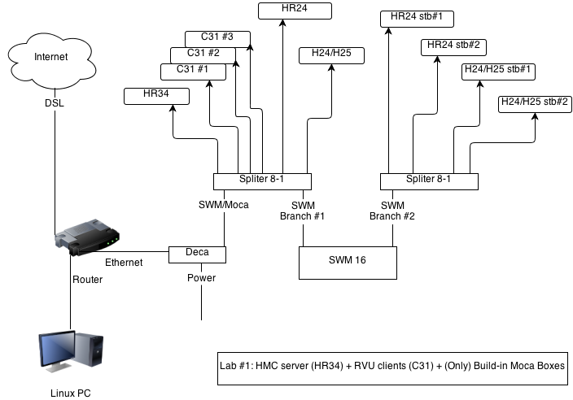
2.1 The new models using Moca network
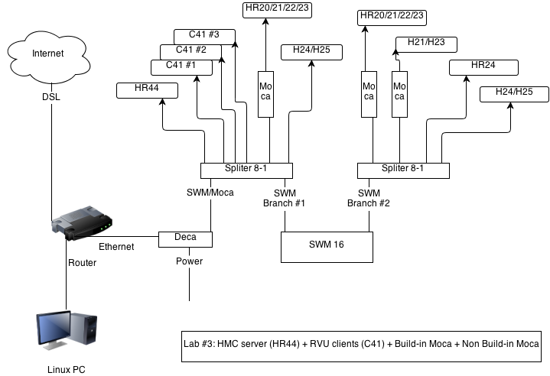
2.2 The old models using Ethernet network

Proposal for New BHT Lab
BHT lab should have enough STBs and types of STB (including Mainline and HMC) to be simulated user’s environment and user’s behaviors.
BHT lab also needs enough supporting devices (such as TVs) for testing.
Basing on new approach we have 4 BHT Labs. Each lab has 2 sites: HMC site and Mainline site with suggested devices:
- Lab #1 (HR34 with build-in Moca devices only):
  - 1 SWM 16
  - Network Moca/Deca, Ethernet (available for test)
  - 1 HR34-700
  - 3 C31
  - 1 H24-100
  - 1 H25-100
  - 1 HR24-100
  - 1 HR24-500
  - Hx2x can be changed/added/removed for testing purpose.
- Lab #2 (HR34 with mixed build-in Moca devices):
  - 1 HR34-700
  - 3 C31
  - 1 H23-600
  - 1 H24-100
  - 1 H25-100
  - 1 HR22-100
  - 1 HR23-700
  - 1 HR24-500
  - Hx2x can be changed/added/removed for testing purpose.
- Lab #2(HR34 with mixed build-in Moca devices):
  - 1 HR34-700
  - 3 C31
  - 1 H23-600
  - 1 H24-100
  - 1 H25-100
  - 1 HR22-100
  - 1 HR23-700
  - 1 HR24-500
  - Hx2x can be changed/added/removed for testing purpose.

- Lab #4 (HR44 with build-in Moca devices only):):
  - 1 SWM 16
  - Network Moca/Deca, Ethernet (available for test)
  - 1 HR44-700
  - 3 C41
  - 1 H24-700
  - 1 H25-500
  - 1 HR24-100
  - 1 HR24-500
  - Hx2x can be changed/added/removed for testing purpose.
- Supporting devices:
- For each lab, we need at least:
  - 1-2 TV to monitor the focused STBs.
  - 1-2 squads to be able to monitor all STBs in the site.
  - Rack system (having 2 plates for 2 sites, HMC and Mainline, on each rack)
  - Power supply
  - Router/Switch

Total Devices for BHT Lab
Total devices for 5 labs:
- Network devices:
  - 5 SWM 16
  - 5 Route/Switch
  - 8 – 16 Moca/Deca (8 Deca and Power), Ethernet cable
- HMC devices:
  - 3 HR34-700
  - 2 HR44-
  - 9 C31
  - 6 C41
- Mainline devices:
  - 3-5 H23-600
  - 3-5 H24-100
  - 3-5 H21-100
  - 3-5 H24-200
  - 3-5 H25-100
  - 3-5 H25-700
  - 3-5 H25-500
  - 3-5 HR22-100
  - 3-5 HR24-100
  - 3-5 HR21-200
  - 3-5 HR24-200
  - 3-5 HR24-500
  - 3-5 HR23-700
- Supporting devices:
  - TVs to monitor the focused STBs
  - Samsung TV (RVU test)
  - Squads to be able to monitor all STBs in the site
  - 5 Rack system
  - Power supply
  - BIT server
  - Digital Modulator
  - Linux

Current Resources
There are testers working on 2 Racks: pure moca rack (lab#1) and mixed moca rack (lab#2).

